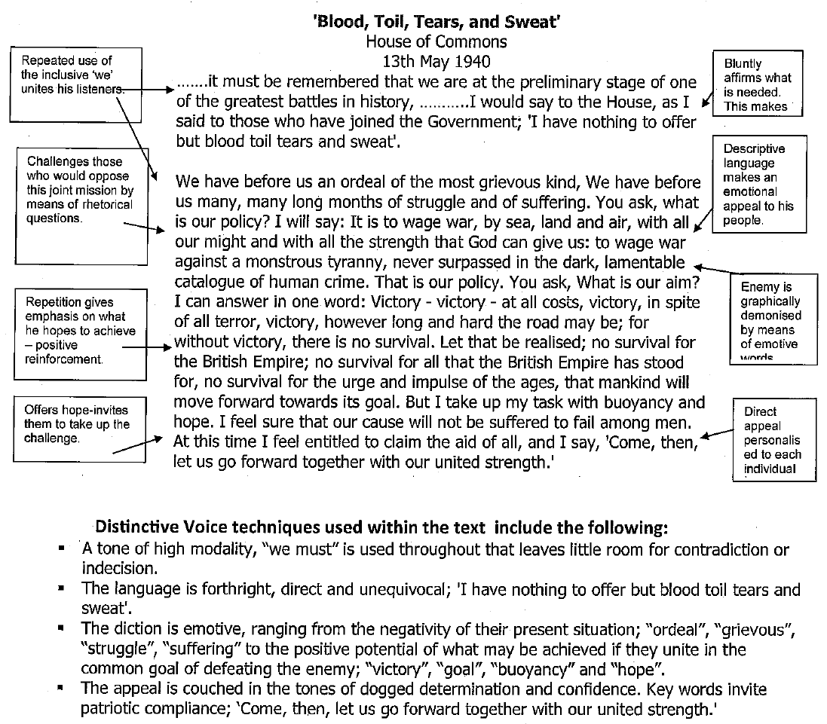
QUESTIONS
- Identify the purpose, audience and register.
- Describe the atmosphere this speech would have fostered.
- Explain how Churchill is able to arouse feelings of patriotism in his audience.
- Compare Churchill’s use of inclusive language at the beginning of the speech to his use of personal pronouns at the end and explain why this is effective.
- Analyse how distinctive voice is created in the text.
- Imagine you had been present in the audience when Churchill delivered his speech. Write a brief diary entry detailing the emotions you felt, what the atmosphere was like in the room and the types of non-verbal language you remember him using for emphasis.

